Week 3 Advanced Security and Final Reporting
Name: Dua Eman
Role: Cybersecurity Intern
Organization: Developer Hub Corporation

1. Introduction
This report presents the Week 3 activities performed during the cybersecurity internship. The focus of this phase was on implementing application logging, performing basic penetration testing, and preparing a security best practices checklist for the vulnerable Node.js web application.

2. Basic Penetration Testing
Basic penetration testing was performed using browser-based testing techniques.
Tests Performed
Invalid Login Testing
Attempted login using invalid credentials.
Empty Field Testing
Tested login functionality with empty input fields.
SQL Injection Testing
Used the following payload during login testing:
admin' OR '1'='1
Observations
- Application frontend showed limited responses due to legacy implementation.
- Security validation logic and backend protections remained active.
- Previous validation tests generated HTTP 400 responses during invalid input handling.

3. Logging Implementation Using Winston
The winston library was installed and configured for application logging.
Installed Package
npm install winston
Implemented Features
- Console logging
- File-based logging
- Security event recording
Logger Configuration
const securityLogger = winston.createLogger({
transports: [
new winston.transports.Console(),
new winston.transports.File({
filename: 'security.log'
})
]
});
Result
A log file named security.log was successfully generated containing application events such as:
{"level":"info","message":"Application started"}

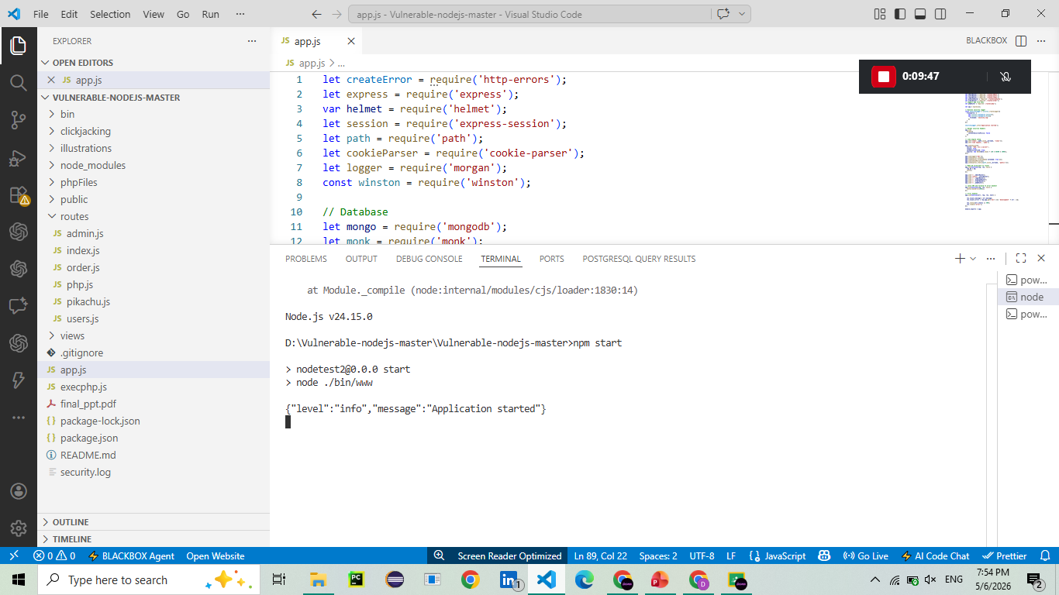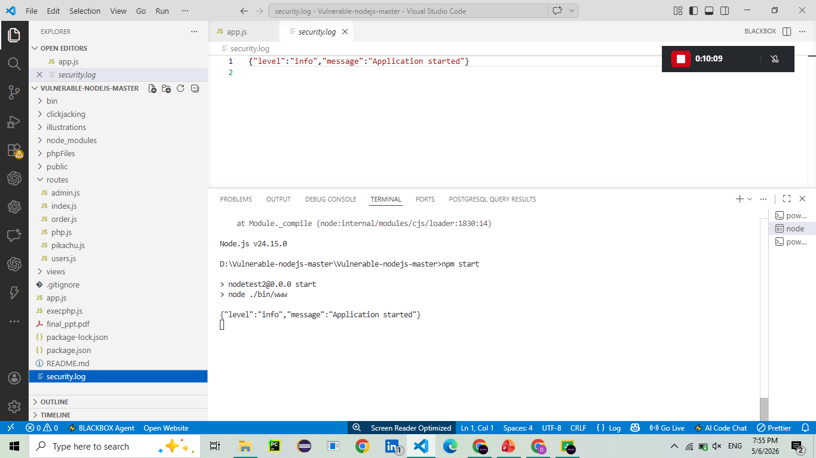
4. Security Checklist
A security checklist was created containing cybersecurity best practices.
Included Best Practices
- Validate all user inputs
- Sanitize incoming data
- Use HTTPS for secure communication
- Hash and salt passwords
- Implement token-based authentication
- Use secure HTTP headers
- Prevent SQL Injection
- Maintain secure session handling
- Monitor logs regularly

5. Tools Used
- Node.js
- Visual Studio Code
- Winston Logger
- Helmet.js
- Validator
- Bcrypt
- JSON Web Token (JWT)
- Chrome Developer Tools
- GitHub

6. Conclusion
Week 3 tasks were successfully completed by implementing logging functionality, conducting penetration testing activities, and documenting essential security practices. The project demonstrated practical cybersecurity concepts including secure authentication, logging, validation, and web application hardening techniques.

Submitted By: Dua Eman

